ELEC-2110

Electric Circuit Analysis

FROM: Jacob Howard

TO: Markus Kreitzer

DATE: August 21, 2019

LAB SECTION: 002

Introduction to MultiSim: DC Analysis

# Introduction

The Objective of this lab was to learn the basic features of MultiSim. MultiSim is a circuit simulation software tool. This tool is a great way to learn circuit education in a safe environment, providing a circuit simulation without expensive tools and preventing possible damage to equipment.

# Exercise 1

In exercise 1, we were asked to use MultiSim to find V0 and Ix in the circuit in Fig. 1 [1]. Figure 1 is below.

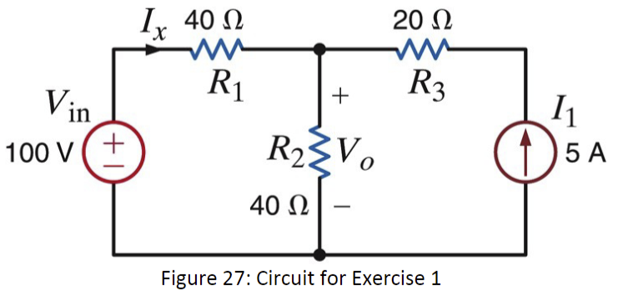

*Figure 1*

Figure 1 was used to construct a circuit in Multisim so we could use Multisim to calculate V0(Unknown Volatage) and Ix (Unknown Current). The circuit constructed is below in figure 2.

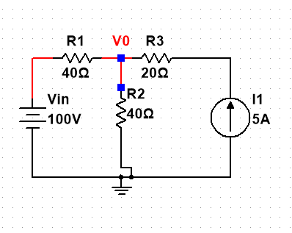

*Figure 2*

Using the circuit constructed in Multisim it was able to calculate V0 and Ix. Found data is listed in Table 1 below.

|  |  |
| --- | --- |
| **V0** | 150 V |
| **Ix** | -1.25A |

*Table 1*

# Exercise 2

In exercise 2, we were asked to use MultiSim to find V0 and the power supplied by the 6-V source in Fig. 3. Figure 3 is included below [1].

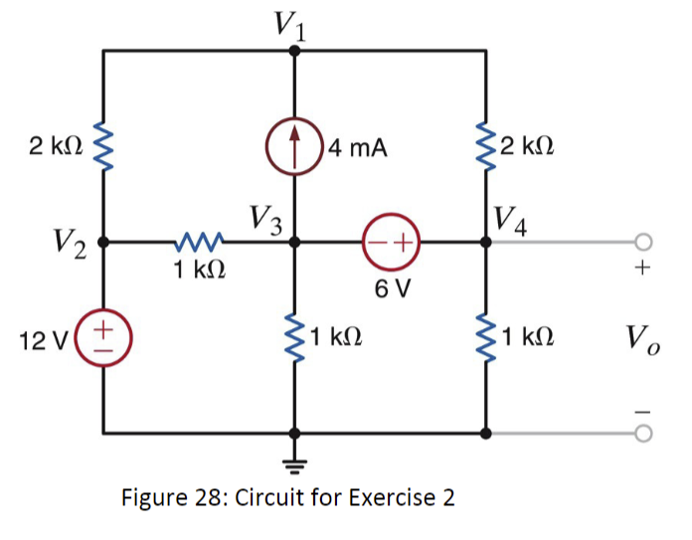

*Figure 3*

Using figure 3, a circuit was constructed in MultiSim so the software could be used to calculate V0 and the power supplied by the 6-V source. Below, in figure 4, is the circuit constructed in MultiSim.

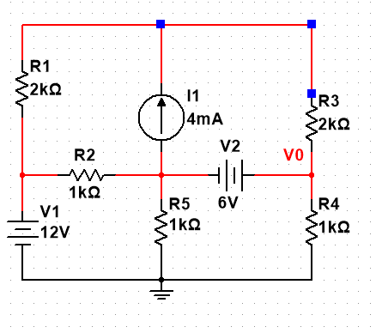

*Figure 4*

Using the circuit constructed in MultiSim from figure 4, The software was able to calculate V0 and the the power supplied by the 6-V source. The data collected is listed below in chart 2.

|  |  |
| --- | --- |
| **V0** | 7.69231 V |
| **6-V Source** | 27.69231 V |

*Chart 2*

# Exercise 3

In exercise 3, we were asked to use the dc sweep feature of MultiSim to plot V0 as the voltage Vin is varied between 50 V and 150 V in steps of 10 V in the circuit of Fig. 5. Figure 5 is listed below [1].

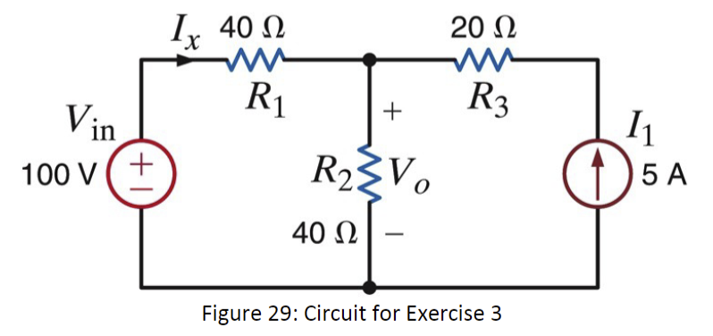

*Figure 5*

Using Figure 29 to construct the circuit and the dc sweep feature in MultiSim, MultiSim was able to show me a graph on how the voltage and the current varies. The circuit constructed in figure 6and the graphs in figure 7 and 8 are below.



Figure 6

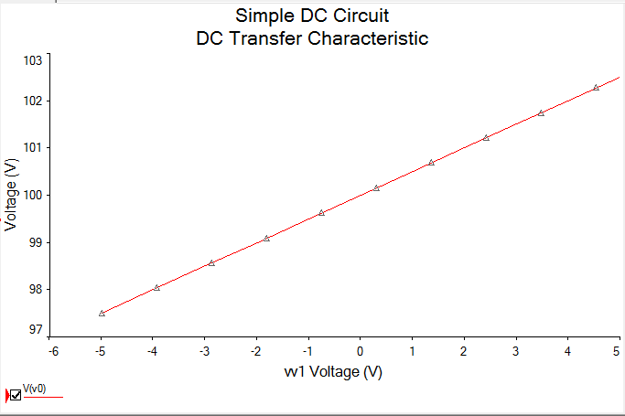

*Figure 7 (Voltage Vary Graph)*

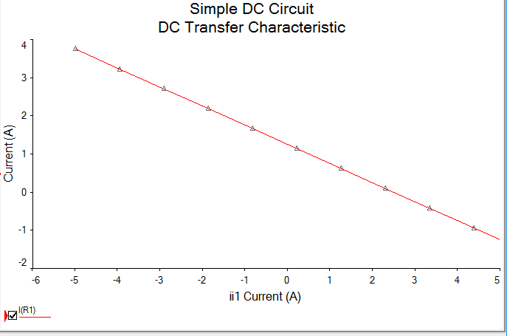

*Figure 8 (Current Vary Graph)*

# Exercise 4

In exercise four, we were asked to use figure 30 and MultiSim to solve for the voltage V0 as Rb varies from 250 Ω to 3 kΩ in increments of 25 Ω. Also solve for the power dissipated in Rb ( P0 ) for each value of resistance. Figure 30 is below [1].

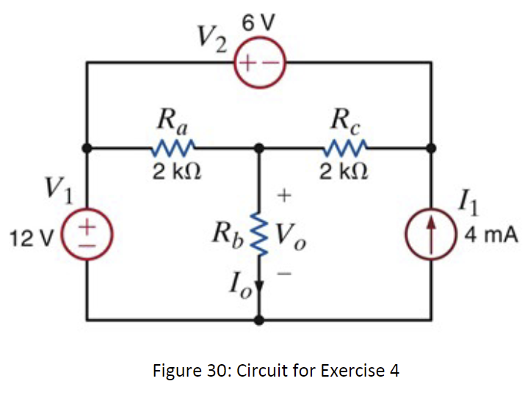

*Figure 9*

Using figure 30 to construct a circuit, MultiSim was used to display a graph for the voltage V0 as Rbvaries from 250 Ω. The circuit constructed in figure 10 and the graph in figure 11 are shown below.

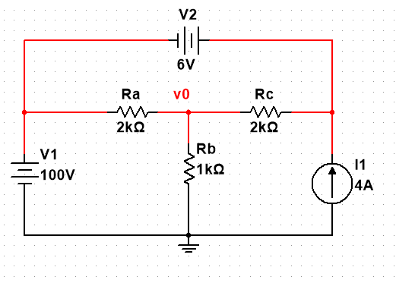

*Figure 10*

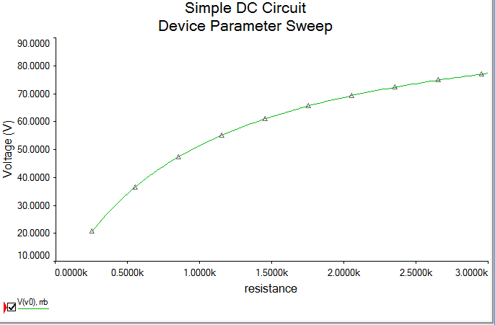

*Figure 11 (Voltage V0 as Rb Varries Graph)*

We were also asked to find the power dissipated in Rb ( P0 ) for each value of resistance. The power dissipated is shown below in figure 12 given by the MultiSim software.

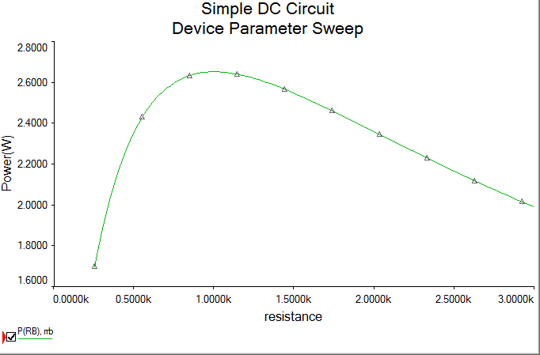

*Figure 12*

# Exercise 5

In exercise five, we were asked to Determine I0 in the circuit in Fig. 13 using MultiSim. Figure 13 is shown below [1].

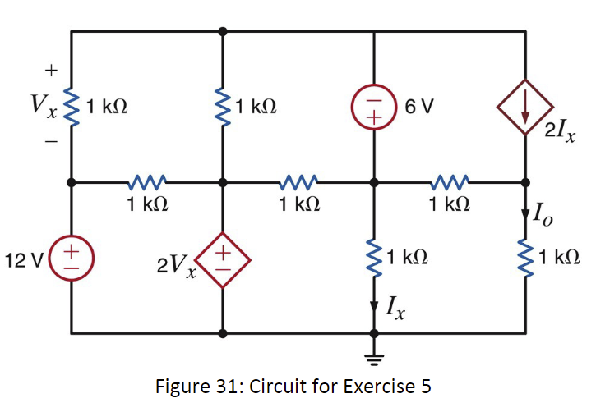

*Figure 13*

Using MutliSims online tool, a circuit was constructed to find I0. The circuit constructed is show below in figure 14 along with I0 in chart 3.

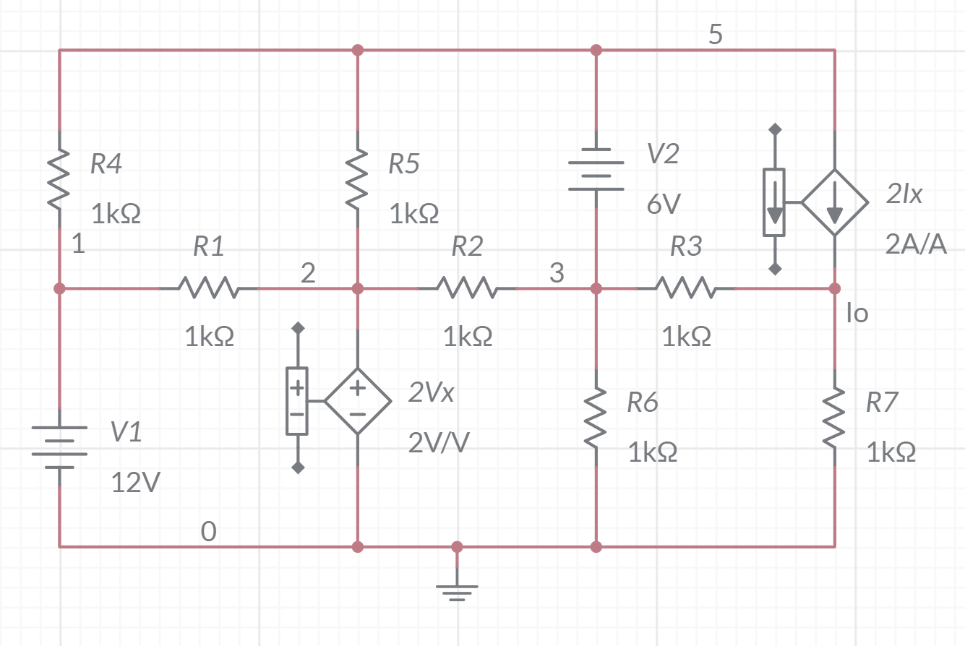

*Figure 14*

|  |  |
| --- | --- |
| **I0** | -48mA |

*Chart 3*

# Conclusion

This lab was used as an introduction on how to use MultiSim. The lab went step by step to show us how to build and simulate a circuit and showed how useful and powerful MultiSim can be. I learned the basics of MultiSim and how to construct circuits, along with displaying certain data, but I did run into some problems. In one instance, I received a negative answer in MultiSim when the answer should have been positive. This is due to MultiSim always assuming the direction of the current. I also had some other issues the finding certain components in MultiSim and building my circuit, but the TA and some fellow students were very helpful. They guided me on certain things, so everything went smoothly. Overall, this lab was a good way to introduce everyone on the basics of MultiSim and how to use it.

# Bibliography

1. Suraj Sindia Elizabeth Devore Bei Zhang. “EXPERIMENT 1 Introduction to MultiSim”. In: (May 2016). url: [ftp://ftp.eng.auburn.edu/pub/irwinjd/lab_manuals/Lab%201_Multisim_](ftp://ftp.eng.auburn.edu/pub/irwinjd/lab_manuals/Lab%201_Multisim_Introduction%20and%20DC%20Analysis.pdf)

[Introduction%20and%20DC%20Analysis.pdf.](ftp://ftp.eng.auburn.edu/pub/irwinjd/lab_manuals/Lab%201_Multisim_Introduction%20and%20DC%20Analysis.pdf)